Target Scope
As a part of the security review process, Crowe had discussed with Jazeera Steel team and identified the key External IPs/Subnets to undergo the security review process. Because of this the below IPS/Subnets has been identified to perform the security review:

IPs included in the assessment:
    - 208.91.199.181

Below table shows findings across all the range of IPs with risk ratings:

# | List of Identified vulnerabilities | Severity
R1 | ISC BIND Multiple Vulnerabilities | High
R2 | My SQL Vulnerable version in Use | High
R3 | Vulnerable version of Exim SMTP in use | Medium
R4 | Vulnerable Version of OpenSSH in use | Medium
R5 | Web Application Potentially Vulnerable to Clickjacking | Medium
R6 | SSL Medium Strength Cipher Suites Supported (SWEET32) | Medium
R7 | TLS Version 1.0 & 1.1 Protocol Detection | Medium
R8 | POP3 Cleartext Logins Permitted | Medium
R9 | Sensitive Services Ports are open | Low

Host | Protocol | Port
208.91.199.181 | udp | 53

Detailed Findings

R1 - ISC BIND Multiple Vulnerabilities

R1 - ISC BIND Multiple Vulnerabilities
Risk Rating: High | CVSS v3 score: 8.5 | Status: Open
Finding:
During the assessment, it was determined that “ISC Bind version 9.11.4-P2”, is affected with multiple vulnerabilities.
Affected IPs:
Risk Description:
The remote host is running “ISC Bind version 9.11.4-P2” is affected with multiple vulnerabilities.
- A memory leak vulnerability exists for named's memory use. An unauthenticated, remote attacker can cause named's memory use to grow without bounds until all memory available to the process is exhausted. (CVE-2018-5744)
- An assertion failure exists in the managed-keys component due to an error when, during key rollover, a trust anchor's keys are replaced with keys which use an unsupported algorithm. An unauthenticated, remote attacker to cause named to deliberately exit after encountering an assertion failure. (CVE-2018-5745)
- A zone transfer vulnerability exists for writable DLZ zones. An unauthenticated, remote attacker can exploit this, via allowzonexfr method bypass, to bypass transfer controls. (CVE-2019-6465)
- DNAME records, described in RFC 6672, provide a way to redirect a subtree of the domain name tree in the DNS. A flaw in the way named processes these records may trigger an attempt to add the same RRset to the ANSWER section more than once. When a vulnerable version of named receives a query for a record triggering the flaw, the named process will terminate due to a failed
assertion check.
Recommendation:
Upgrade to the latest versions of ISC's BIND 9 are:
- Development Version: BIND 9.21.3, released in December 2024.
- New Stable Version: BIND 9.20.4, released in December 2024, with support until Q2 2028.
- Current Stable Extended Support Version (ESV): BIND 9.18.32, released in December 2024, with support until Q2 2026.
For production environments, it's recommended to use the New Stable Version, BIND 9.20.4, to benefit from the latest features and extended support.
References:
https://www.isc.org/download/?utm_source=chatgpt.com

Supporting Evidence:
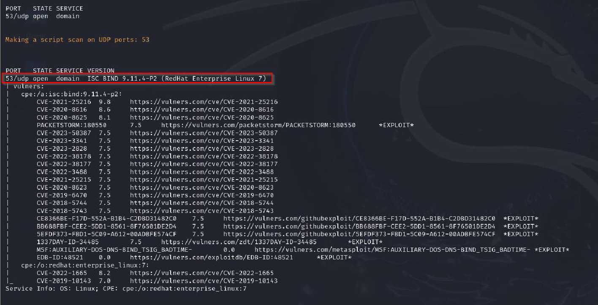
Figure: Nmap output showing that the remote host is running unsupported “ISC Bind version 9.11.4-P2”.
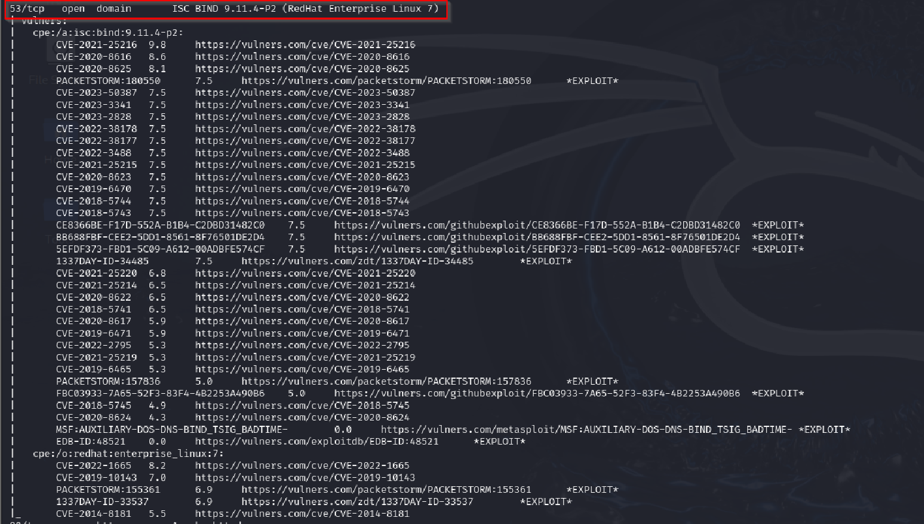
Figure: Browser Screenshot Showing CVE details of ISC Bind version 9.11.4-P2.

Host | Protocol | Port
208.91.199.181 | tcp | 3306

R2 – My SQL Vulnerable version in Use

R2 - My SQL Vulnerable version in Use
Risk Rating: High | CVSS v3 score: 8.5 | Status: Open
Finding:
During the assessment, it was found that the Remote Host Running My SQL version 5.7.23-23 which is affected with Publicly Known Vulnerabilities.
Affected IPs:
Risk Description:
The Remote Host running My SQL version 5.7.23-23 which is affected with Publicly Known Vulnerabilities.
- CVE-2018-2767: A vulnerability in the Security: Encryption subcomponent, allowing a low-privileged attacker with network access to cause a denial of service (DoS) through a complete hang or crash of MySQL Server.
- CVE-2018-3054: A flaw in the DDL subcomponent, enabling an attacker to cause a hang or crash, leading to a DoS condition.
- CVE-2018-3056: A vulnerability in the Security: Privileges subcomponent, which could be exploited to cause a hang or crash, resulting in a DoS.
- CVE-2018-3058: An issue in the MyISAM subcomponent, allowing an attacker to cause a hang or crash, leading to a DoS condition.
- CVE-2018-3060: A flaw in the InnoDB subcomponent, which could be exploited to cause a hang or crash, resulting in a DoS.
- CVE-2018-3061: A vulnerability in the DML subcomponent, allowing an attacker to cause a hang or crash, leading to a DoS condition.
- CVE-2018-3062: An issue in the Memcached subcomponent, which could be exploited to cause a hang or crash, resulting in a DoS.
Successful Exploitation May cause an authenticated attacker can send data over a network to an affected MySQL Server when configured to run an Extended Event session, an authenticated attacker could exploit the vulnerability by executing a specially crafted query using $ partition against a table with a Column Store index.
Recommendation:
Upgrade to a version of MySQL Server that is currently supported. If a piece of software has passed its end of life, the user or organization should implement an immediate plan to phase out that software in favor of software that is currently maintained.
Organizations should also use a patch management system to keep software up to date without disrupting business as usual. There are several commercial patch management systems such as Microsoft Windows Server Update Services (WSUS), Kaseya Patch Management, and Patch Manager from SolarWinds, that organizations may choose to employ for this purpose.
Reference:
https://www.mysql.com/support/supportedplatforms/database.html https://www.mysql.com/support/eol-notice.html

Supporting Evidence :
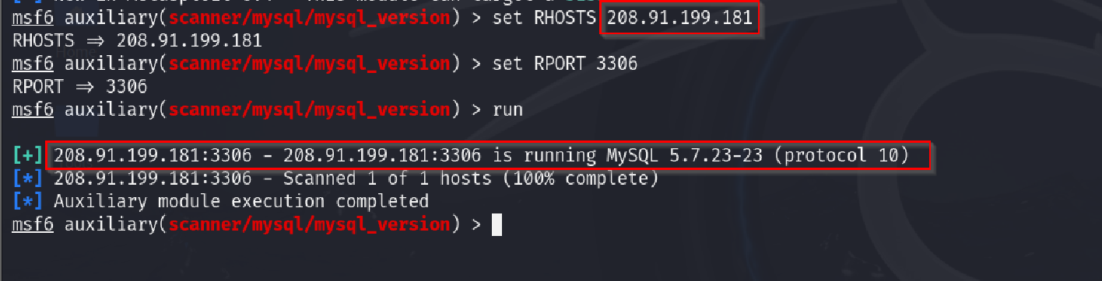
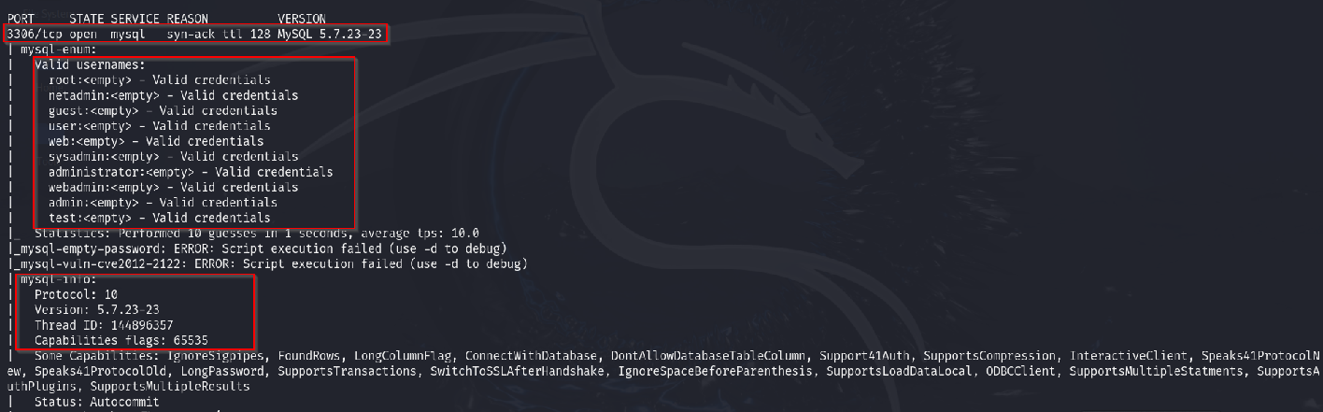

Figure: Exim SMTP.
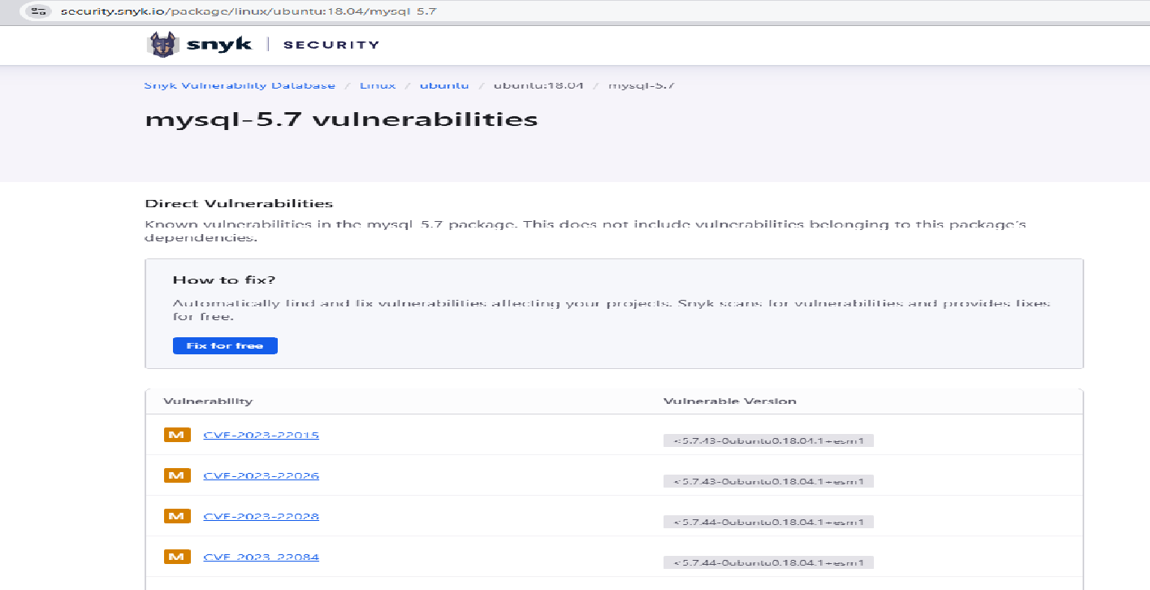
Figure: Browsing screenshot showing CVE details of My SQL 5.7.23-23

R3 - Vulnerable version of Exim SMTP in use

R4 - Vulnerable version of Exim SMTP in use
Risk Rating: Medium |  |  | CVSS v3 score: 6.5 |  | Status: Open
Finding:
During the assessment, it was determined that the Exim SMTP version 4.96.2 which is affected with Publicly Known Vulnerabilities.
Affected IPs:
 | Host | Protocol | Port
 | 208.91.199.181 | tcp | 587
Risk Description:
The Remote Host running Exim SMTP version 4.96.2 which is affected with Publicly Known Vulnerabilities.
- CVE-2023-42115: An out-of-bounds write in the SMTP service's handling of AUTH commands, enabling unauthenticated remote attackers to execute arbitrary code.
- CVE-2023-42116: A stack-based buffer overflow during NTLM challenge request processing, which could be exploited for remote code execution.
- CVE-2023-42117: Improper neutralization of special elements, leading to memory corruption and potential remote code execution.
- CVE-2023-42118: A flaw in the libspf2 library's SPF macro processing, allowing remote code execution due to improper integer validation.
- CVE-2023-42119: An out-of-bounds read in the dnsdb function, resulting in information disclosure.
Successful Exploitation May cause an authenticated attacker can send data over a network to an affected Exim SMTP Server when configured to run an Extended Event session, an authenticated attacker could exploit the vulnerability by executing a specially crafted query using $ partition against a table with a Column Store index.
Recommendation:
It is recommended to disable SNMP or use a hardened SNMPv3-only configuration. If SNMPv2 must be
used, change the community string to a non-standard and not easily guessable format.

Supporting Evidence:
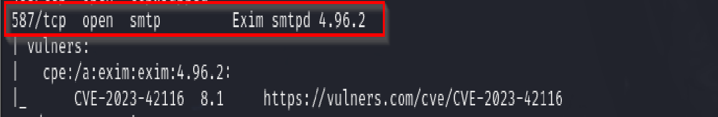
Figure: Nmap output showing that Remote server using Exim SMTP 4.96.2.

Host | Protocol | Port
208.91.199.181 | tcp | 22

R4 – Vulnerable Version of OpenSSH in use

R4 - Vulnerable Version of OpenSSH in use
Risk Rating: Medium | CVSS v3 score: 5 | Status: Open
Finding:
During the assessment, it was determined that there were multiple hosts detected with Vulnerable OpenSSH versions.
Affected IPs:
Risk Description:
The remote server is running a version of OpenSSH which contains known vulnerabilities. OpenSSH is an open-source software library based on the SSH protocol that provides remote login, secure FTP, and other network services that allow users to communicate securely over computer networks. In general, published vulnerabilities have a greater likelihood of exploitation by attackers due to readily available proof-of- concept code that exploits the issue, or integrates the exploits into freely available testing tools. The vulnerabilities present in OpenSSH (and subsequently the impact of exploit) depend on the version currently deployed. Certain versions of OpenSSH are vulnerable to denial-of-service attacks that prevent legitimate users from accessing resources hosted on the affected server. Other vulnerabilities present in specific versions of OpenSSH may allow an attacker to elevate their user privileges on the server, gain unauthorized access to sensitive information, or impersonate other users on the affected server.
Recommendation:
Upgrade to the latest version of OpenSSH. Organizations should also use a patch management system to keep software up to date without disrupting ongoing business. There are a number of commercial patch management systems such as Microsoft Windows Server Update Services (WSUS), Kaseya Patch Management, and Patch Manager from SolarWinds, that organizations may choose to employ for this purpose.
Reference:
https://attackerkb.com/topics/Btbi0LZGQd/cve-2003-0190 https://www.cvedetails.com/version-list/97/585/1/Openbsd-Openssh.html

Supporting Evidence:
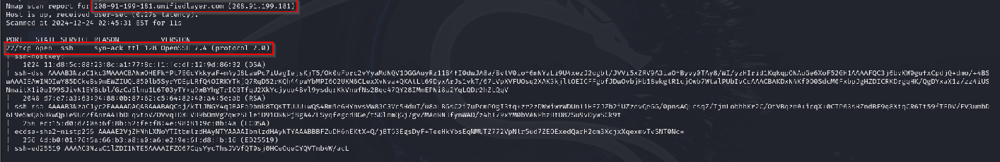
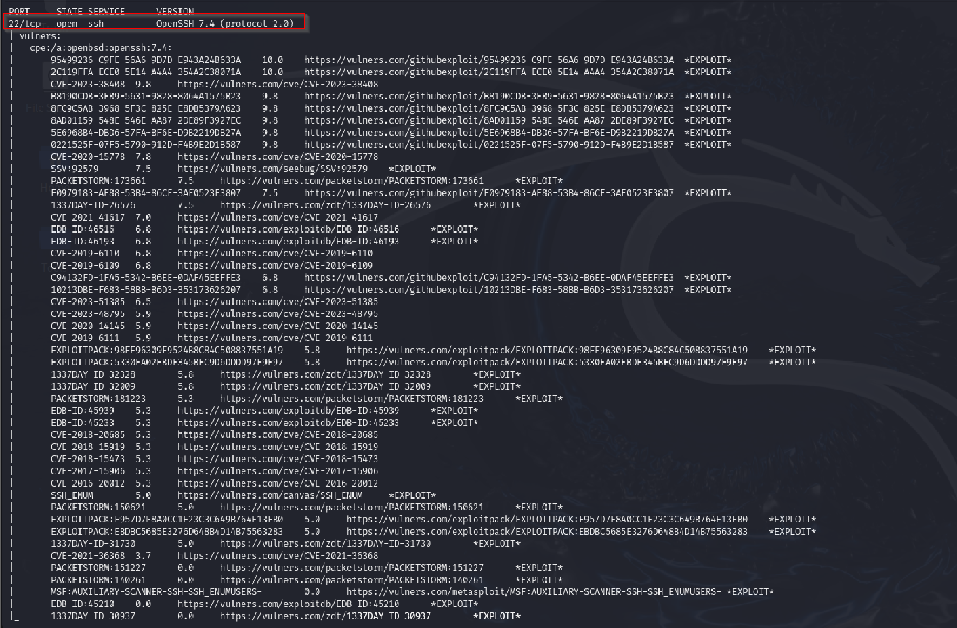
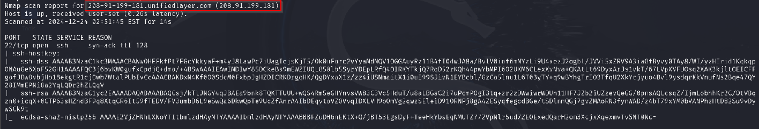

Figure: Nmap output Showing the remote host running “OpenSSH version 7.4”

R5 - Web Application Potentially Vulnerable to Clickjacking
Host | Protocol | Port
208.91.199.181 | tcp | 443

R5 - Web Application Potentially Vulnerable to Clickjacking
Risk Rating: Medium | CVSS v3 score: 5.4 | Status: Open
Finding:
During the assessment, it was determined that the remote hosts are vulnerable to Clickjacking attack.
Affected IPs:
Risk Description:
Clickjacking is used to trick a user into thinking they are clicking on a UI element on a visible page, when the click is actually captured by an entirely different element on an invisible layer. This results in the victim unintentionally carrying out an action on behalf of the attacker. Examples include allowing access to the client computer's hardware features (e.g., enabling the webcam) or submitting a form to initiate an unintended transaction (such as one-click online shopping, "liking" a Facebook page, initiating a money
transfer, etc.).
Recommendation:
To prevent Clickjacking, web application should return a response HTTP header with X-Frame-Option set to DENY preventing framing altogether, or the value SAMEORIGIN to allow framing only by pages on the same origin as the response itself. Three partial solutions currently exist: 1. Use of "frame-breaking" scripts on pages that should never be incorporated into other frames. e.g., <script>if (top! =self) top. location. href=self. location. href</script> 2. Use of the non-standard "X-FRAME-OPTIONS" header. These indicate that the current page should not be loaded in a frame, supporting browsers currently include IE8+, Safari 4+, Chrome 2+. 3. Use of the Cross-Origin Resource Sharing headers, which indicate acceptable cross-origin requests. (Known to be supported in Firefox 3.5+ and IE8+).
Reference:
https://www.owasp.org/index.php/Clickjacking

Supporting Evidence:
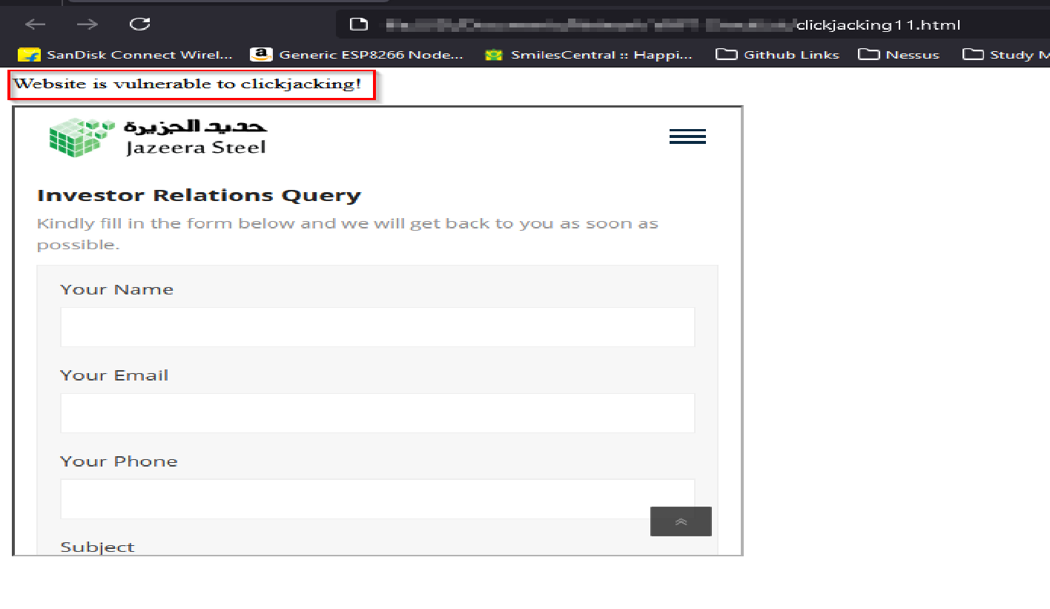
Figure: Browser screenshot showing the application pages are loading inside an iFrame.

R6 - SSL Medium Strength Cipher Suites Supported (SWEET32)

R6 - SSL Medium Strength Cipher Suites Supported (SWEET32)
Risk Rating: Medium |  |  | CVSS v3 score: 6.5 |  |  | Status: Open
Finding:
During the assessment, it was determined that the remote host supports weak ciphers such as 3DES_EDE_CBC_SHA.
Affected IPs:
 | Host | Protocol |  | Port
 | 208.91.199.181 | tcp |  | 2078
 | 208.91.199.181 | tcp |  | 2083
 | 208.91.199.181 | tcp |  | 2087
 | 208.91.199.181 | tcp |  | 2096
Risk Description:
Cipher Suites that use block cipher algorithms with small block size like Triple-DES (3DES); these ciphers are susceptible to birthday attacks according to a recent discovery known as the "Sweet 32" vulnerability, allowing attackers to find collisions in a reasonably sized traffic sample. Please refer to the below link for more details:
https://cve.mitre.org/cgi-bin/cvename.cgi?name=CVE-2016-2183.
Recommendation:
The server-side TLS endpoint's configuration should be updated to allow only TLS v1.2 and TLS v1.3 connections with strong cipher suites. TLS v1.3 is a new standard that only supports strong ciphers with authenticated encryption (AEAD). To provide good security TLS v1.2 must be configured to only use cipher suites that have:
- Elliptic Curve Diffie-Hellman Ephemeral (ECDHE) for key exchange to support Forward Secrecy
- Block ciphers (e.g., AES) in GCM mode (avoid use of CBC)
An example of such a cipher suite is TLS_ECDHE_ECDSA_WITH_AES_128_GCM_SHA256 (also known as ECDHE-ECDSA-AES128-GCM-SHA256).
Reference:
https://www.openssl.org/blog/blog/2016/08/24/sweet32/

Supporting Evidence:
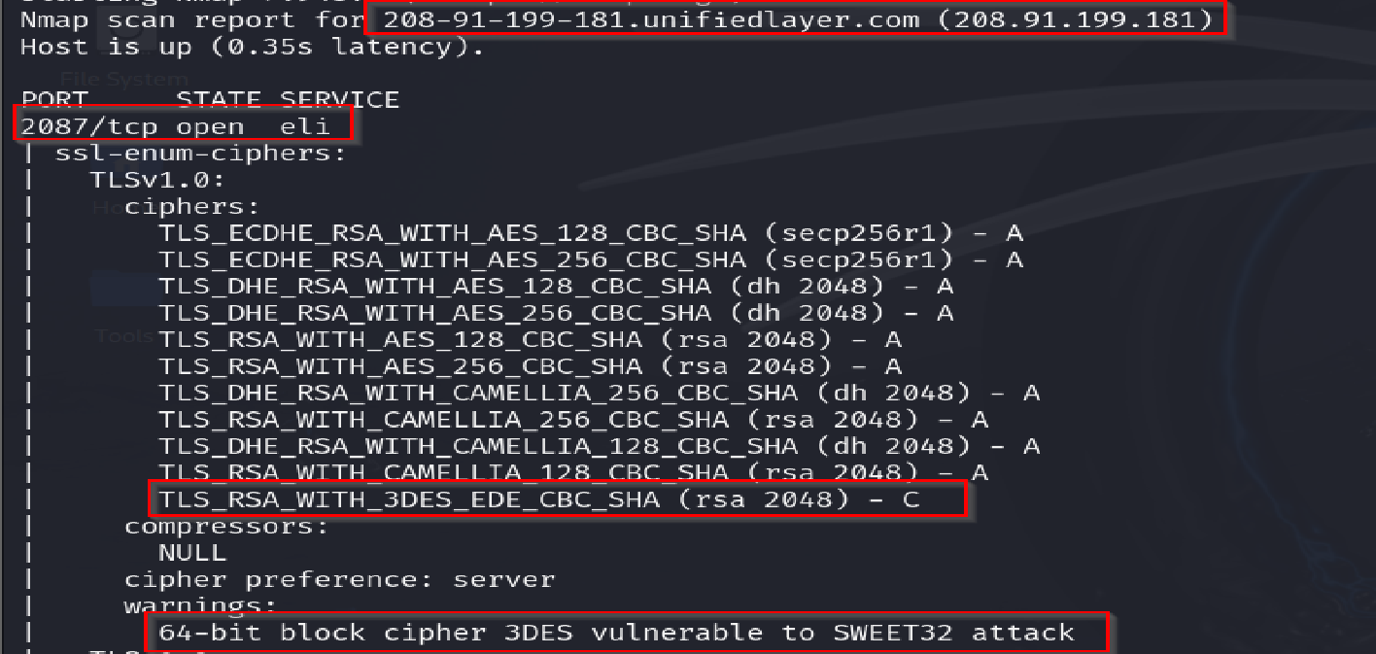
Figure: Nmap output showing remote host supports weak ciphers such as 3DES_EDE_CBC_SHA.
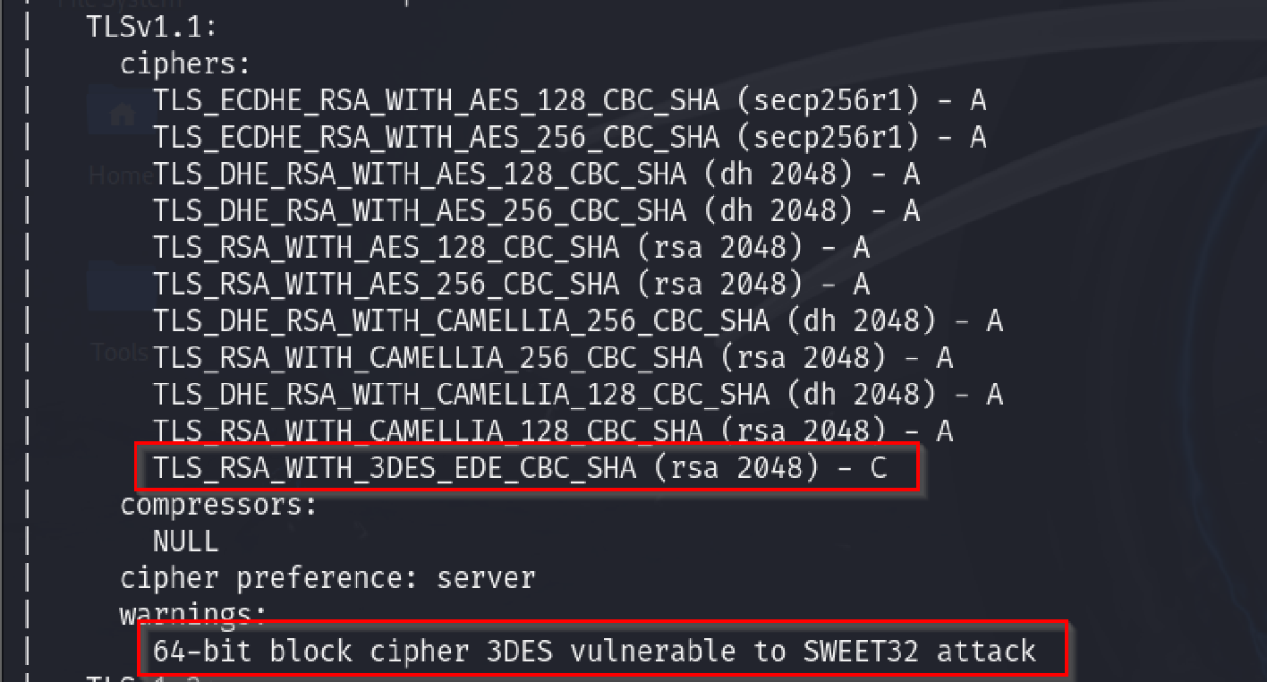
Figure: Nmap output showing remote host supports weak ciphers such as 3DES_EDE_CBC_SHA.



TlSvl.2: ciphers:
- A
- A

TlS_ECDHE_RSA_WITH_AES_128_GCM_SHA256 (secp256rl) TlS_ECDHE_RSA_WITH_AES_256_GCM_SHA384 (secp256rl) TlS_DHE_RSA_WITH_AES_128_GCM_SHA256 (dh 2048) - A TlS_DHE_RSA_WITH_AES_256_GCM_SHA384 (dh 2048) - A TlS_ECDHE_RSA_WITH_AES_128_CBC_SHA256 (secp256rl) - A TlS_ECDHE_RSA_WITH_AES_128_CBC_SHA (secp256rl) - A TlS_ECDHE_RSA_WITH_AES_256_CBC_SHA384 (secp256rl) - A TlS_ECDHE_RSA_WITH_AES_256_CBC_SHA (secp256rl) - A TlS_DHE_RSA_WITH_AES_128_CBC_SHA256 (dh 2048) - A TlS_DHE_RSA_WITH_AES_128_CBC_SHA (dh 2048) - A TlS_DHE_RSA_WITH_AES_256_CBC_SHA256 (dh 21048) - A TlS_DHE_RSA_WITH_AES_256_CBC_SHA (dh 2048) - A TlS_RSA_WITH_AES_128_GCM_SHA256 (rsa 2048) - A TlS_RSA_WITH_AES_256_GCM_SHA384 (rsa 2048) - A TlS_RSA_WITH_AES_128_CBC_SHA256 (rsa 2048) - A TlS_RSA_WITH_AES_256_CBC_SHA256 (rsa 2048) - A TlS_RSA_WITH_AES_128_CBC_SHA (rsa 2048) - A TlS_RSA_WITH_AES_256_CBC_SHA (rsa 2048) - A TlS_DHE_RSA_WITH_CAMEllIA_256_CBC_SIHA (dh 2048) - A TlS_RSA_WITH_CAMEllIA_256_CBC_SHA (rsa 2048) - A TlS_DHE_RSA_WITH_CAMEllIA_128_CBC_SIHA (dh 2048) - A TIS_RSA_WTTH_CAMFII TA_1?8_CRC_SHA (rsc1 ?048) - A TlS_RSA_WITH_3DES_EDE_CBC_SHA (rsa 2048) - C

compressors:

NUlL

cipher preference: server warnin2:s:

64-bit block cipher 3DES vulnerable to SWEET32 attack

R7 - TLS Version 1.0 & 1.1 Protocol Detection

R7 - TLS Version 1.0 & 1.1 Protocol Detection
Risk Rating: Medium | CVSS v3 score: 6.5 | Status: Open
Finding:
During the assessment, it was determined that the remote host supports deprecated protocols such as
“TLSv1.0” and “TLSv1.1”.
Affected IPs:
Host Protocol Port
208.91.199.181 tcp 2078
208.91.199.181 tcp 2083
208.91.199.181 tcp 2087
208.91.199.181 tcp 2096
Risk Description:
The server-side SSL/TLS endpoint is configured to allow connections using TLS protocol version 1.1 ("TLSv1.1”), which contains known weaknesses. Certain configurations of TLS version 1.1 are vulnerable to known man-in-the-middle ("MitM") attacks, including the BEAST and POODLE attacks. Weaknesses in TLSv1.0 connections may allow an attacker to decrypt traffic passed between a victim's client and the server. Any sensitive information passed over this connection may be exposed, such as credentials, account data, personally identifiable information (PII), financial records, etc. Exposure of session identifiers may allow an attacker to hijack a victim's session and impersonate the victim in the application. An attacker who decrypts
traffic in transit between a victim's client and the server may also modify data in transit, allowing them to modify requests the victim has initiated, and any data being returned to the client.
Recommendation:
- The server-side TLS endpoint's configuration should be updated to allow only TLS v1.2 and TLS v1.3 connections with strong cipher suites. TLS v1.3 is a new standard that only supports strong ciphers with authenticated encryption (AEAD). To provide good security TLS v1.2 must be configured to only use cipher suites that have:
- Elliptic Curve Diffie-Hellman Ephemeral (ECDHE) for key exchange to support Forward Secrecy
- Block ciphers (e.g., AES) in GCM mode (avoid use of CBC)
- An example of such a cipher suite is TLS_ECDHE_ECDSA_WITH_AES_128_GCM_SHA256 (also known as ECDHE-ECDSA-AES128-GCM-SHA256).
Reference:
https://tools.ietf.org/html/draft-ietf-tls-oldversions-deprecate-00

Supporting Evidence:
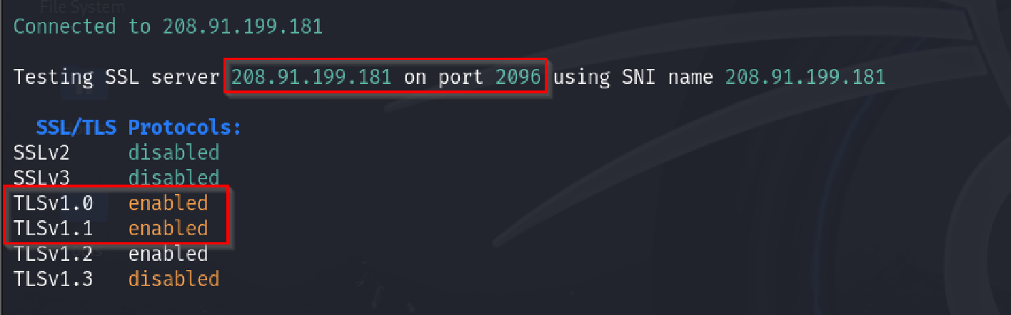
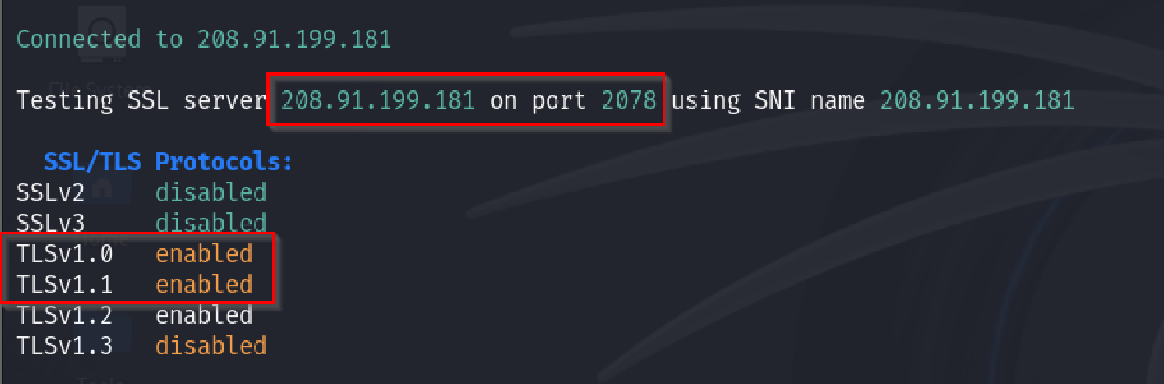

Figure: The remote hosts support deprecated protocols TLSv1.0 and TLSv1.1.

Host | Protocol | Port
208.91.199.181 | tcp | 110

R8 - POP3 Cleartext Logins Permitted

R8 - POP3 Cleartext Logins Permitted
Risk Rating: Medium | CVSS v3 score: 4.9 | Status: Open
Finding:
During the assessment, it was found that the X.509 certificate chain is not signed by a recognized certificate authority and is self-signed.
Affected IPs:
Risk Description:
The "POP3 Cleartext Logins Permitted" vulnerability indicates that the mail server allows users to authenticate using unencrypted credentials (username and password) over an unencrypted connection. This exposes sensitive information to interception, especially when data is transmitted over untrusted networks, such as public Wi-Fi or the internet.
Risks:
- Credential Interception:
  - Attackers can capture usernames and passwords using packet-sniffing tools, leading to unauthorized access to email accounts.
- Account Compromise:
  - Stolen credentials can be used for phishing, spamming, or accessing sensitive information in the compromised mailbox.
- Non-Compliance:
  - Allowing cleartext logins may violate security standards like PCI DSS, HIPAA, or GDPR.
Recommendation:
- Enforce Encryption (STARTTLS or SSL/TLS):
  - Configure the POP3 server to enforce encryption during client-server communication.
- Disable Cleartext Authentication
- Redirect Port 110 to Encrypted Port 995 (POP3 over SSL/TLS)
Reference:
https://www.itu.int/rec/T-REC-X.509/en https://en.wikipedia.org/wiki/X.509

Supporting Evidence:
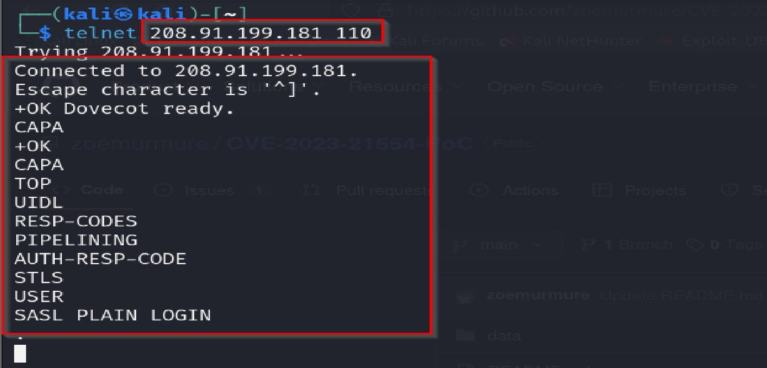
Figure: Screenshot showing POP3 Clear text login is permitted.

Host | Protocol | Port | Host | Protocol | Port
208.91.199.181 | udp | 53 | 208.91.199.181 | tcp | 2083
208.91.199.181 | tcp | 21 | 208.91.199.181 | tcp | 2086
208.91.199.181 | tcp | 80 | 208.91.199.181 | tcp | 2095
208.91.199.181 | tcp | 2077 | 208.91.199.181 | tcp | 3306
208.91.199.181 | tcp | 2078 | 208.91.199.181 | tcp | 143
208.91.199.181 | tcp | 995 | 208.91.199.181 | tcp | 993
208.91.199.181 | tcp | 587 | 208.91.199.181 | tcp | 53
208.91.199.181 | tcp | 22 | 208.91.199.181 | tcp | 25
208.91.199.181 | tcp | 2087 | 208.91.199.181 | tcp | 26
208.91.199.181 | tcp | 2096 | 208.91.199.181 | tcp | 465
208.91.199.181 | tcp | 2082 | 208.91.199.181 | tcp | 2222
208.91.199.181 | udp | 161

R9 - Sensitive Services Ports are open

R9 – Sensitive Services Ports are open
Risk Rating: Low | CVSS v3 score: 3.5 | Status: Open
Finding:
During the penetration testing activity, it was observer that the sensitive service ports such as SSH and SMTP and other ports are Open.
Affected IPs:
Risk Description:
Exposing sensitive ports on an external IP address can have significant security implications. These ports often correspond to services critical to system functionality, and their exposure increases the attack surface of the network. Below are the risks and potential impacts:
- Increased Risk of Exploitation
  - Attack Surface Expansion: Open ports are entry points into a system. If these are tied to services with known vulnerabilities, attackers can exploit them.
  - Automated Scanning: Tools like Nmap and masscan can detect open ports, making the system a target for opportunistic attackers.
  - Brute Force Attacks: Ports associated with authentication services (e.g., SSH, RDP) are prone to password- guessing or brute-force attacks.
- Unauthorized Access
  - Unprotected Services: Services like databases (MySQL, MongoDB), file-sharing protocols (SMB, FTP), or remote management (SSH, RDP) are often not hardened for external access.
  - Lateral Movement: Once an attacker gains access through an open port, they may use it to pivot into internal systems.
- Data Exposure
  - Sensitive Data Leakage: Misconfigured services might expose sensitive data (e.g., unsecured databases or HTTP APIs on open ports).
  - Man-in-the-Middle (MitM) Attacks: Lack of encryption on services like POP3, IMAP, or FTP can result in intercepted credentials or sensitive data.
- Denial of Service (DoS)
  - Service Disruption: Attackers can exploit open ports to overwhelm a service with requests, causing downtime.
  - Resource Exhaustion: Critical services running on open ports can be overwhelmed, impacting legitimate users.
- Non-Compliance with Regulations

- Open ports exposing sensitive services may lead to non-compliance with standards like PCI DSS, HIPAA, or
GDPR, resulting in fines or penalties.
Recommendation:
- Minimize Exposed Ports:
  - Use a firewall to restrict access to sensitive ports.
  - Close unnecessary ports and disable unused services.
- Restrict Access:
  - Allow access only from trusted IP addresses using access control lists (ACLs).
  - Implement VPNs for external access to sensitive services.
- Use Secure Protocols:
  - Replace insecure protocols (e.g., Telnet) with secure alternatives (e.g., SSH).
  - Enable encryption for all communications.
- Regular Monitoring:
  - Scan external-facing IPs using tools like Nmap to identify open ports.
  - Use intrusion detection systems (IDS) to monitor for suspicious activity.
- Authentication and Hardening:
  - Enforce strong authentication mechanisms (e.g., SSH keys, multi-factor authentication).
  - Regularly update and patch exposed services.
Reference:
https://community.apigee.com/articles/6400/how-to-update-an-expired-ssl-certificate-without-c.html

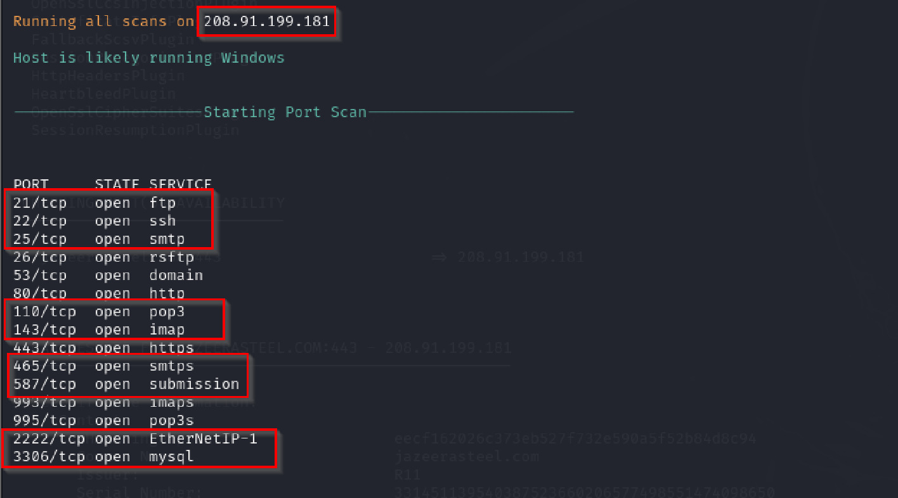
Supporting Evidence:
Figure: Nmap output showing Sensitive Service ports are open.

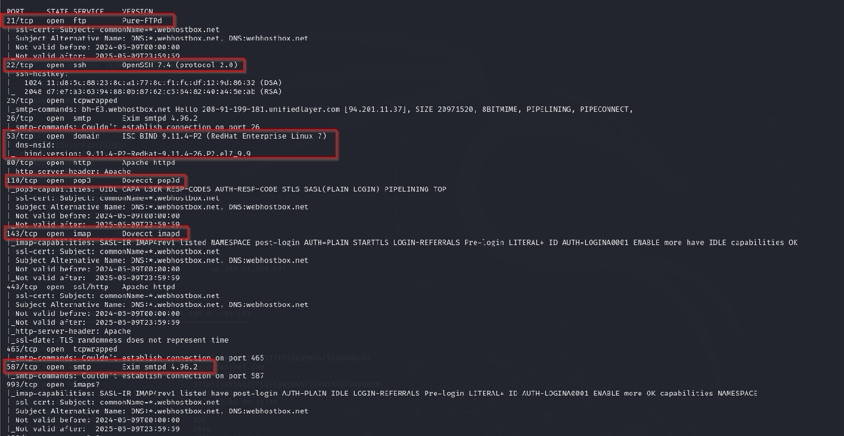
Figure: Nmap output showing Sensitive Service ports are open.

Conclusion
External Vulnerability Assessment resulted in the following:
- 09 vulnerabilities- 00 Critical, 02 High, 06 Medium and 01 Low findings.
Fixing the vulnerabilities identified in this exercise would greatly reduce the risk exposure of the IPs.
We suggest having a managed service model of performing an effective vulnerability management program and quarterly audit of all the internal IP addresses.

*****************************************END OF REPORT******************************************

